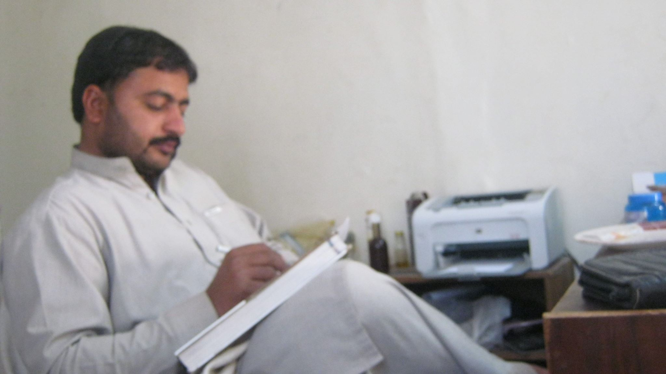 CURRICULUM VITAE

PERSONAL DATA:
LAST NAME: (ALL CAPS) Name as it appears on your passport:
First Name: Asad
Physical Street Address for courier delivery (NOT A POSTAL BOX):
Telephone Home: 091-555766
Telephone Mobile: 034188383464
Telephone Office:
Email 1: asad@yahoo.com
Marital Status: Single
Date of Birth: 25/December/1996
Gender: Male
Country of Origin: Pakistan
Present Nationality: Paskistani
Languages and Fluency Level: Advance

EDUCATION:
Degree Earned,
MSc, London School of Hygiene & Tropical Medicine, Keppel Street, London
WC1E 7HT, UK, 08/1996 to 06/1998.
Bsc,abdul wali khan univ mardan 07/1994 to 02/1996.

WORK HISTORY:
Medical Officer, National Hospital, Lagos, Nigeria, 02/1999-Present, Supervisor: Dr. Chikwe
Adatsi
- Bullet list the duties associated with your position and your main accomplishments

- Begin with the most recent position and work backwards. List all subsequent entries in the same manner and include bullet points for main duties, activities and accomplishments.

TRAINING AND PROFESSIONAL DEVELOPMENT:
Course Name, Venue (Institution, Address), Date
Example:
Epidemiology for Public Health Professionals, Emory University, Atlanta, Georgia,
USA, 09/25/2006 – 10/27/2006.

- It is not necessary to list publications or presentations on your CV for STOP purposes.

- Photos on the CV are not necessary

